**PRACTICAL NO. 5**

**AIM: Authentication and Configuration of VLAN.**

**1.Configuration of PPPoE: -**

**a.PAP**

**b.CHAP**

**2.Create Dial-up network using WAN cloud**

**3.Configure VLANs on the router**

**4. Design InterVLAN, Router on stick, multilayer VLAN.**

**5. Configure Spanning tree.**

**THEORY:**

**Configuration of PPPoE**

PPPoE (Point-to-Point Protocol over Ethernet) is a specification for connecting multiple computer users on an [Ethernet](https://searchnetworking.techtarget.com/definition/Ethernet) [local area network](https://searchnetworking.techtarget.com/definition/local-area-network-LAN) to a remote site through common [customer premises equipment](https://searchnetworking.techtarget.com/definition/customer-premises-equipment), which is the telephone company's term for a [modem](https://searchmobilecomputing.techtarget.com/definition/modem) and similar devices. PPPoE can be used to have an office or building-full of users share a common Digital Subscriber Line (DSL), [cable modem](https://searchsecurity.techtarget.com/definition/cable-modem), or [wireless](https://searchmobilecomputing.techtarget.com/definition/wireless) connection to the Internet. PPPoE combines the Point-to-Point Protocol ([PPP](https://searchnetworking.techtarget.com/definition/PPP)), commonly used in dialup connections, with the Ethernet protocol, which supports multiple users in a local area network. The PPP protocol information is encapsulated within an Ethernet [frame](https://searchnetworking.techtarget.com/definition/frame).

PPPoE has the advantage that neither the telephone company nor the Internet service provider ([ISP](https://searchwindevelopment.techtarget.com/definition/ISP)) needs to provide any special support. Unlike dialup connections, DSL and cable modem connections are "always on." Since a number of different users are sharing the same physical connection to the remote service provider, a way is needed to keep track of which user traffic should go to and which user should be billed. PPPoE provides for each user-remote site session to learn each other's network addresses (during an initial exchange called "discovery"). Once a session is established between an individual user and the remote site (for example, an Internet service provider), the session can be monitored for billing purposes. Many apartment houses, hotels, and corporations are now providing shared Internet access over DSL lines using Ethernet and PPPoE.We can configure PPPoE with PAP & CHAP.

**1)Configure PPPoE using PAP**

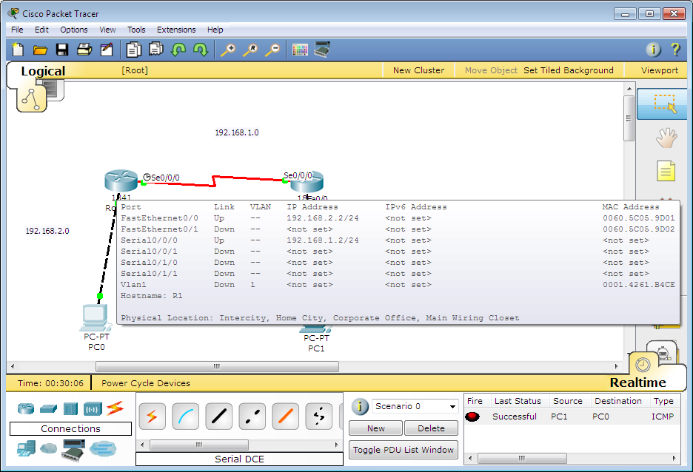

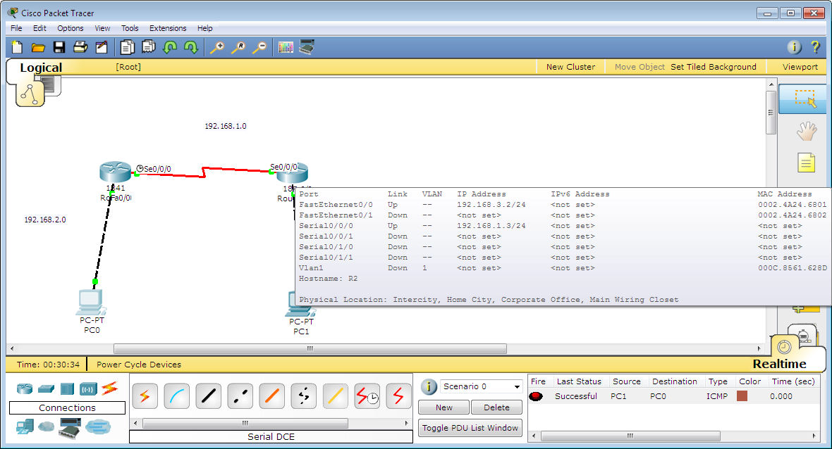

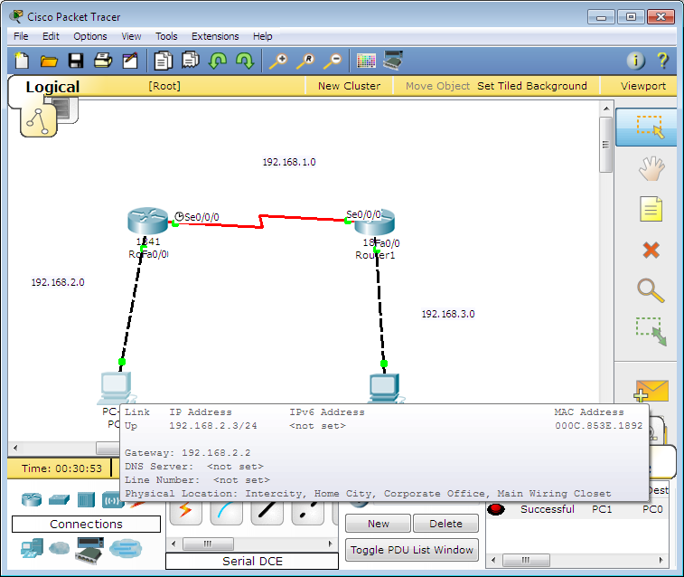

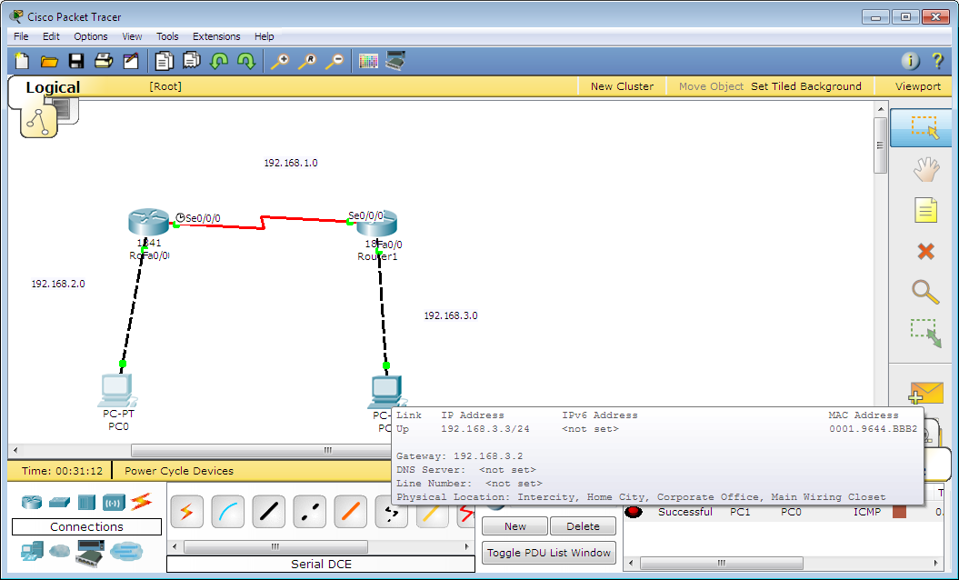

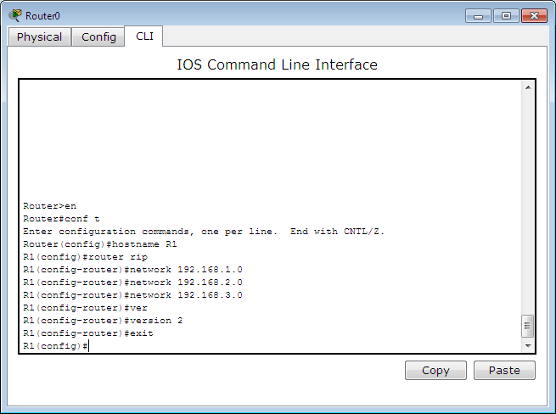

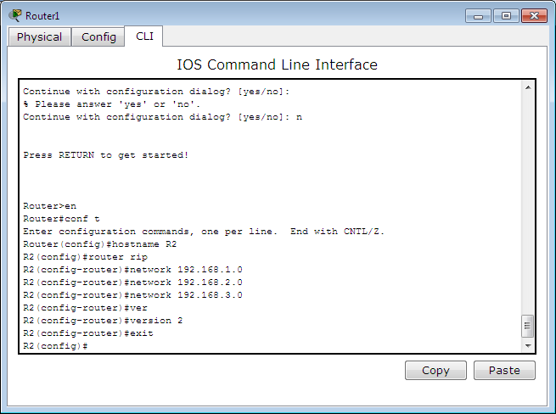

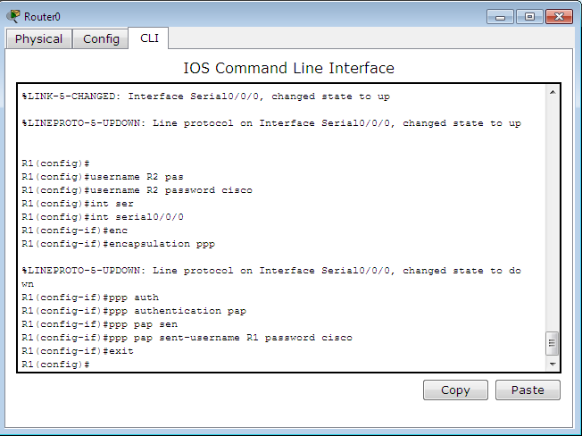

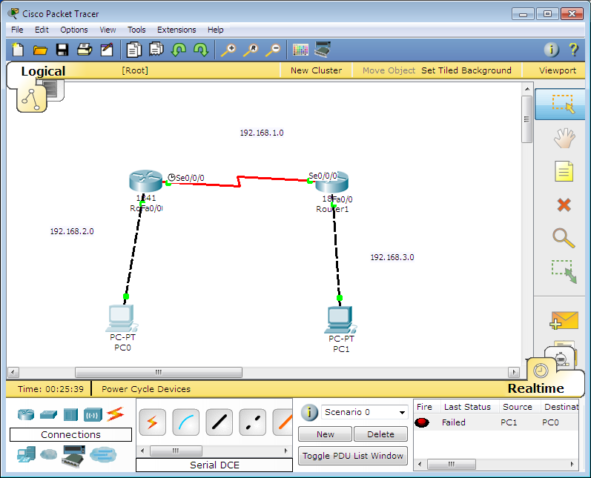

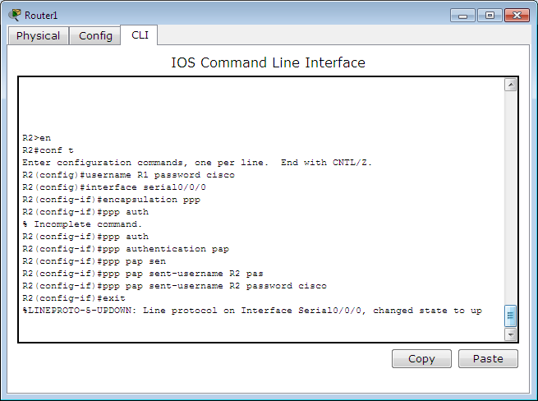

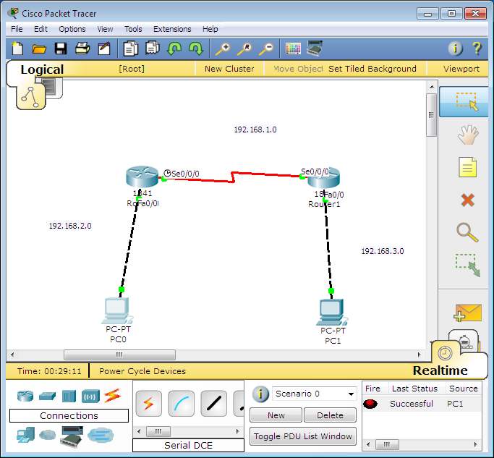

**Configure PPPoE using CHAP**













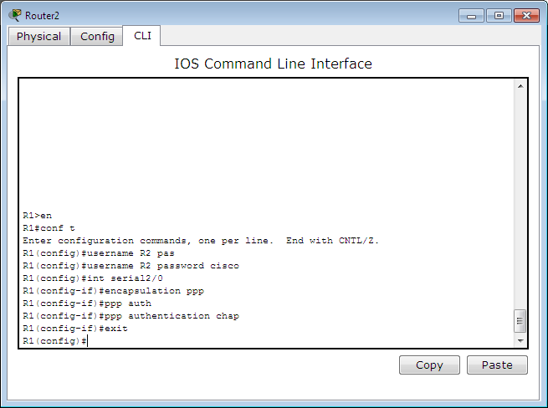

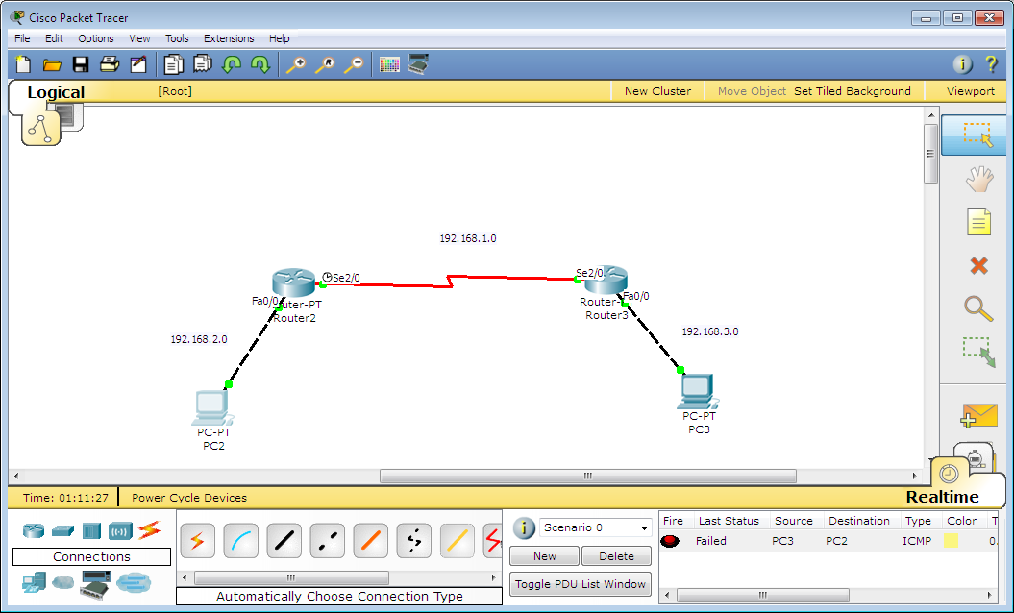

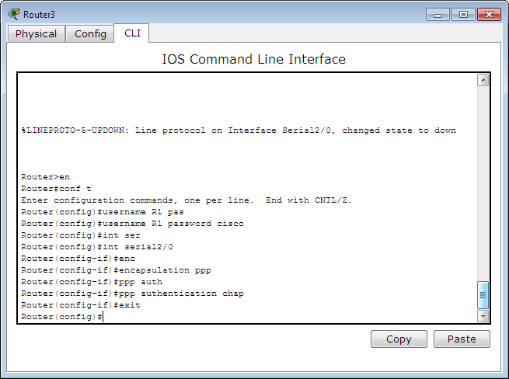



**2)Create Dial-up network using WAN cloud:**

Dial-Up Networking (DUN) is a utility in Windows 95 and Windows 98 that enables the user’s system to connect to a network through a modem. Dial-Up Networking was useful in days when LAN was not common and connecting to the Internet was via configuration of Dial-Up Networking to dial into a point of presence (POP) and connect to an Internet service provider (ISP).

Cloud technology is pushing WAN technology toward the consumer paradigm, as a raft of new start-ups make it easier to provision and deploy WAN services in the cloud with a software-only model. The WAN functionality moving into the cloud includes business-class Internet, security, WAN optimization, and application policy control.

This cloud WAN movement, or as some call it software-defined WAN (SD-WAN), is designed to make WAN services easier to consume and manage. It's part of two megatrends in networking, including software-defined networking (SDN) and the consumerization of enterprise technology.

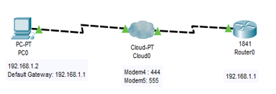

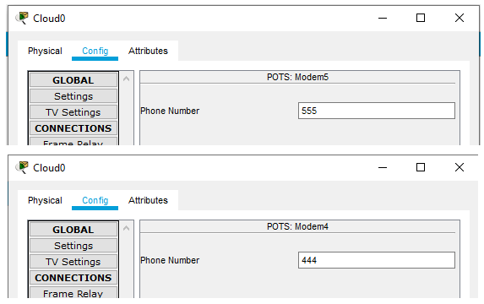

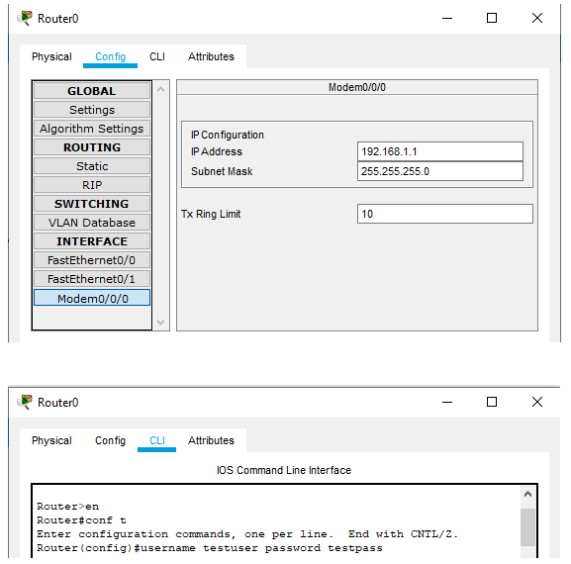

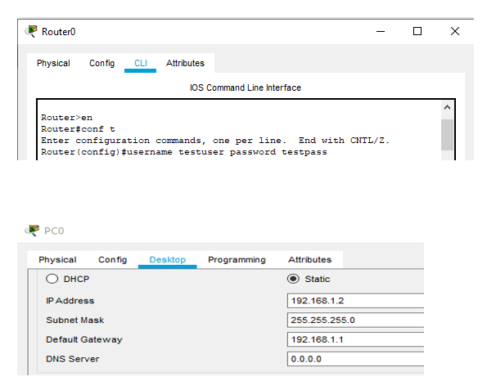

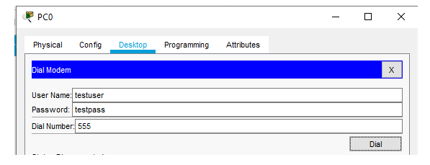

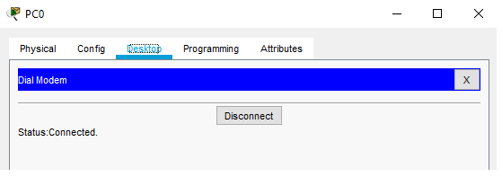

**3)Configure VLANs on the router:**

VLANs (Virtual LANs) are logical grouping of devices in the same broadcast domain. VLANs are usually configured on switches by placing some interfaces into one broadcast domain and some interfaces into another. VLANs can be spread across multiple switches, with each VLAN being treated as its own subnet or broadcast domain. This means that frames broadcasted onto the network will be switched only between the ports within the same VLAN. A VLAN acts like a physical LAN, but it allows hosts to be grouped together in the same broadcast domain even if they are not connected to the same switch.

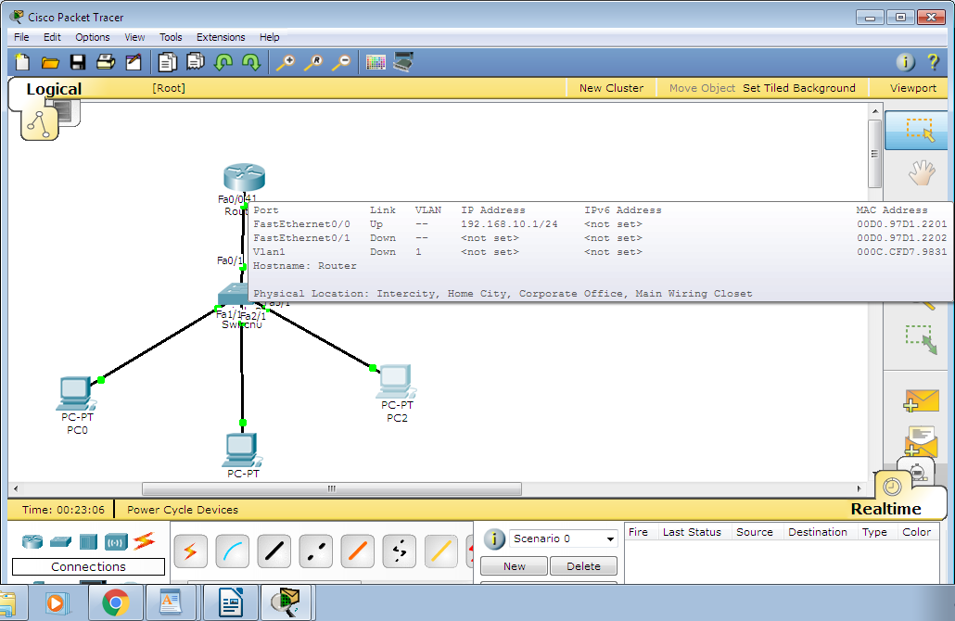

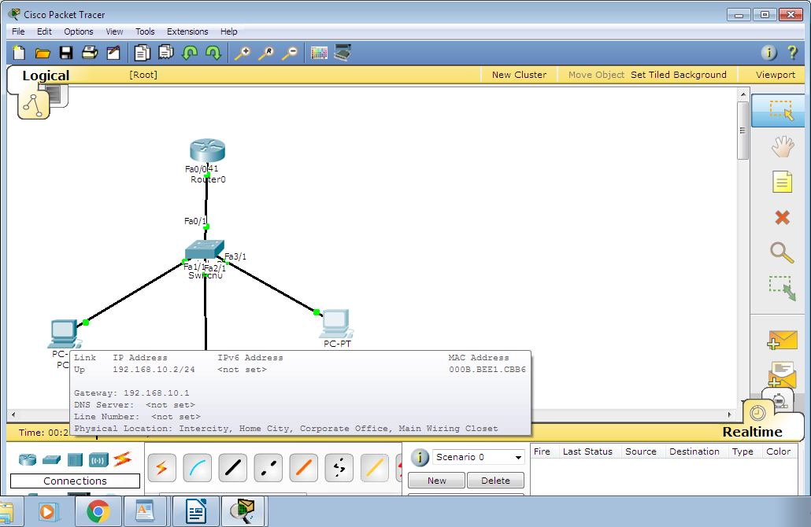

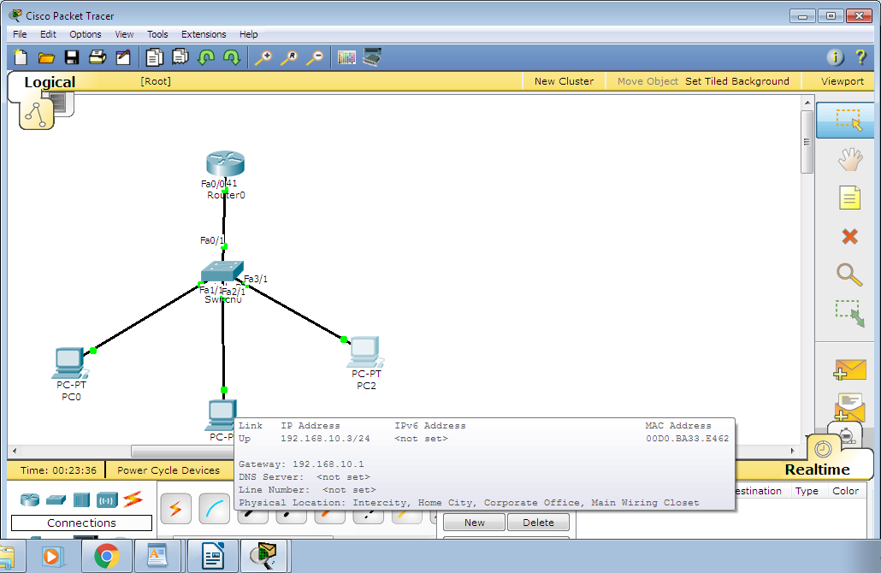

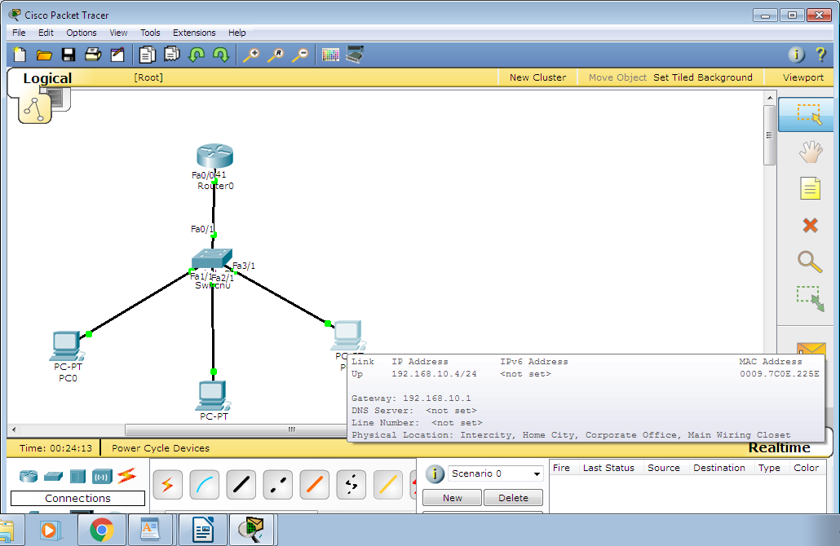

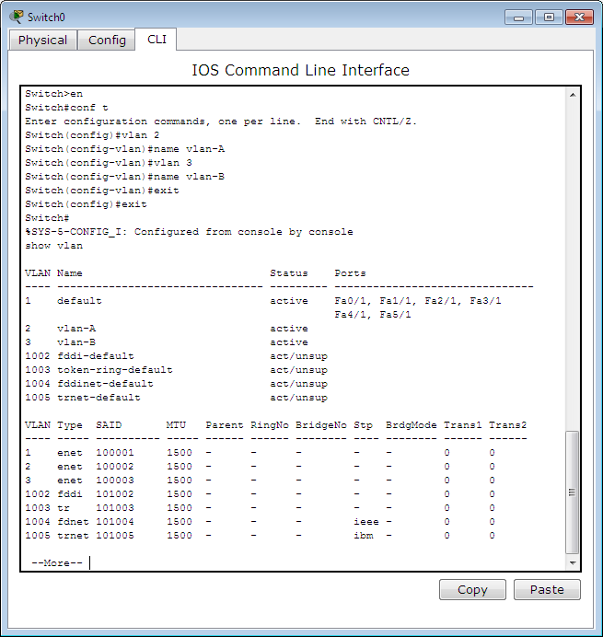

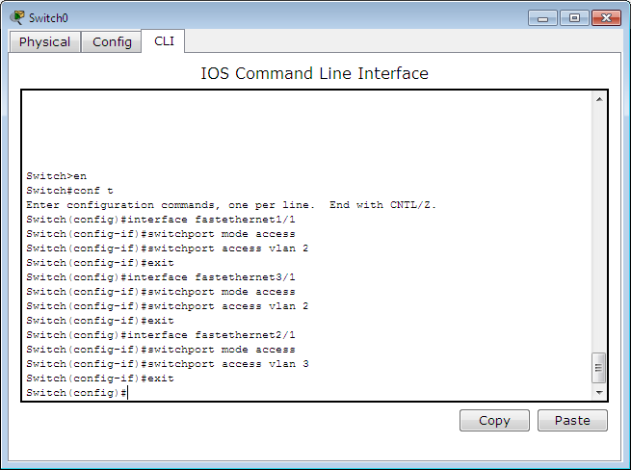

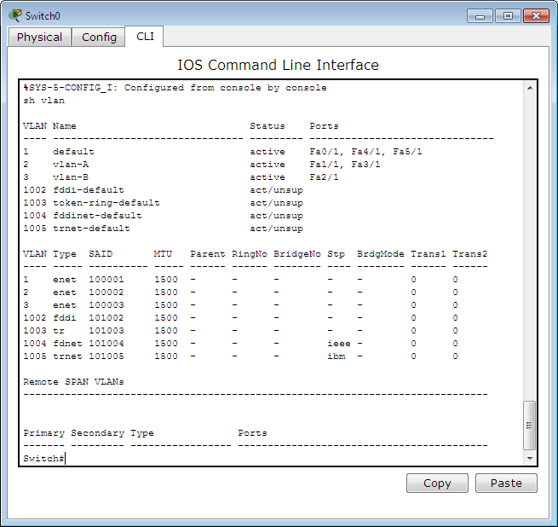

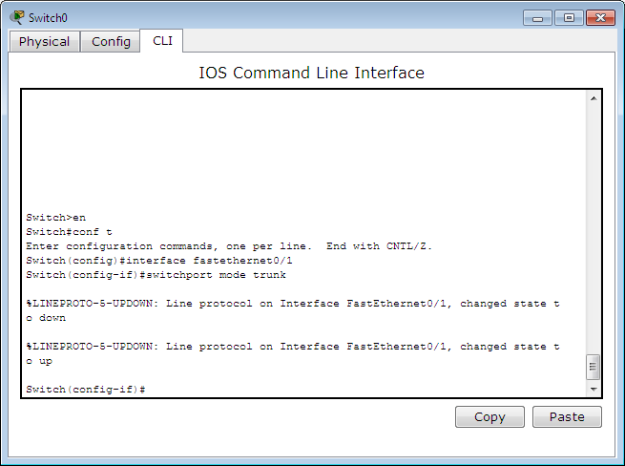

**4)Design InterVLAN, Router on stick, multilayer VLAN.**









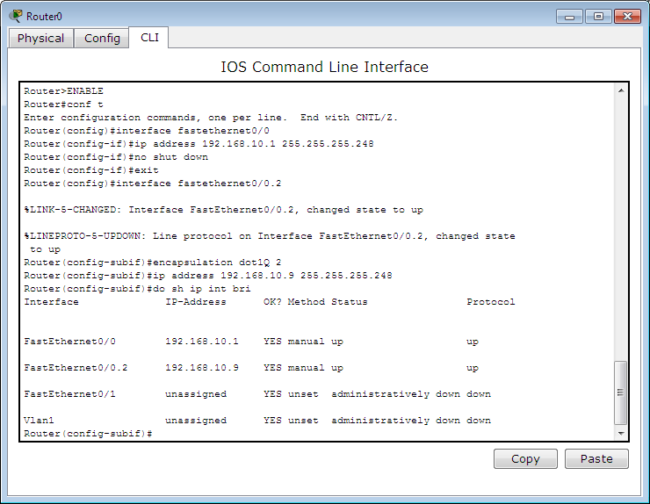

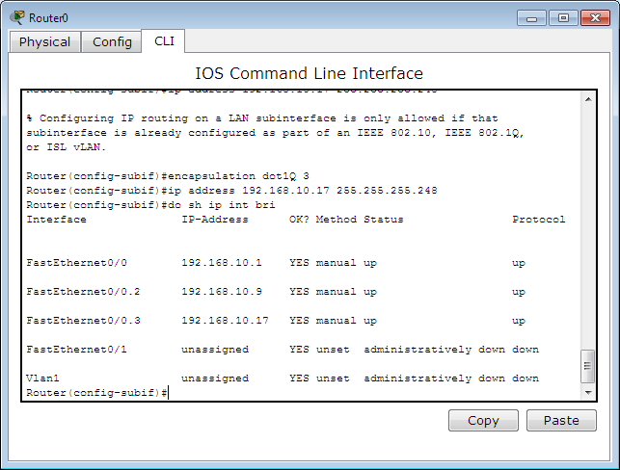

**5)Configure Spanning Tree**

The Spanning Tree Protocol (STP) is a [network protocol](https://en.wikipedia.org/wiki/Network_protocol) that builds a loop-free [logical topology](https://en.wikipedia.org/wiki/Logical_topology) for [Ethernet networks](https://en.wikipedia.org/wiki/Ethernet_network). The basic function of STP is to prevent [bridge loops](https://en.wikipedia.org/wiki/Bridge_loop) and the [broadcast radiation](https://en.wikipedia.org/wiki/Broadcast_radiation) that results from them. Spanning tree also allows a [network design](https://en.wikipedia.org/wiki/Network_planning_and_design) to include backup links providing [fault tolerance](https://en.wikipedia.org/wiki/Fault_tolerance) if an active link fails.

As the name suggests, STP creates a [spanning tree](https://en.wikipedia.org/wiki/Spanning_tree_(mathematics)) that characterizes the relationship of nodes within a network of connected layer-2 [bridges](https://en.wikipedia.org/wiki/Network_bridge), and disables those links that are not part of the spanning tree, leaving a single active path between any two network nodes. STP is based on an algorithm that was invented by [Radia Perlman](https://en.wikipedia.org/wiki/Radia_Perlman" \o "Radia Perlman) while she was working for [Digital Equipment Corporation](https://en.wikipedia.org/wiki/Digital_Equipment_Corporation)

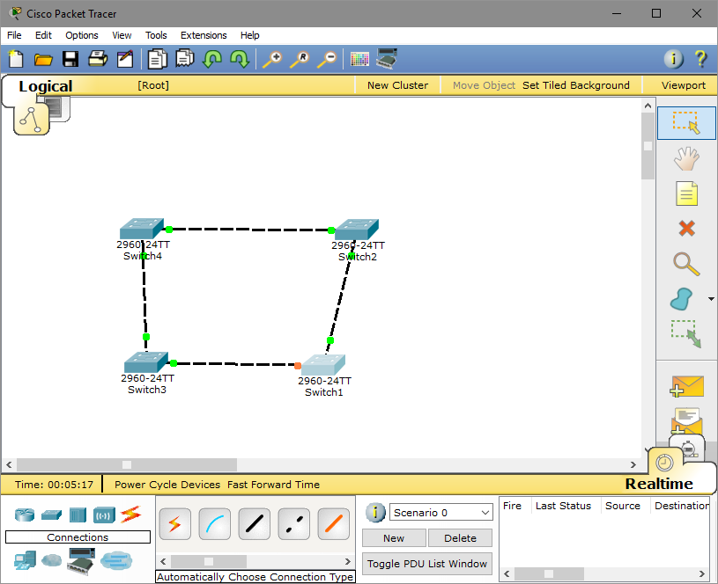

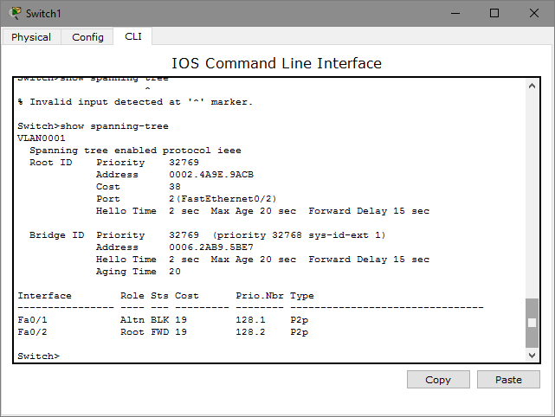

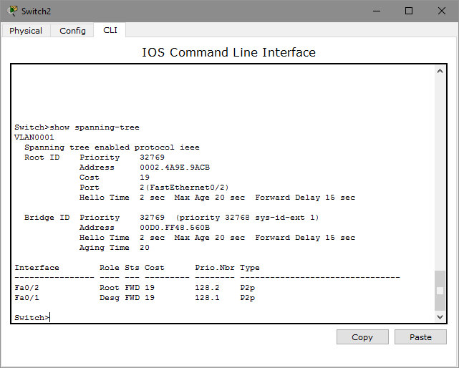

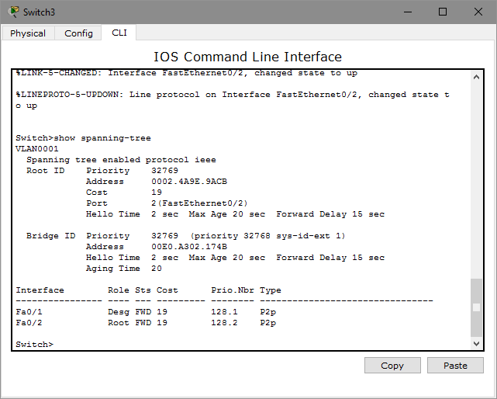

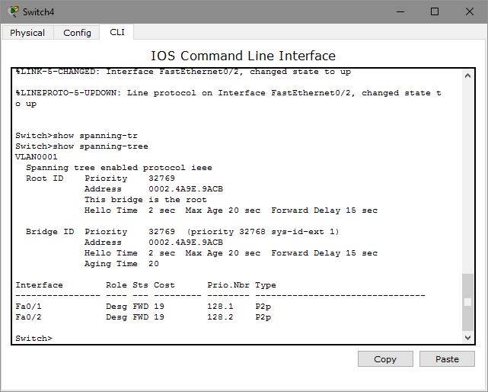

**CONCLUSION:**

We have successfully authenticated and configured VLAN by Configuration of PPPoE, Dial-up network using WAN cloud, Configure VLANs on the router, Design InterVlan, Router on stick, Multiplayer VLAN & Configuration of spanning tree